**Computer Networks and Network Security: Lab Assignment One**

**Due Oct. 14, 2021 in class or by email to the instructor.** This assignment gives you a chance to analyze communication systems.

* [P1 (5 points)] Try to use traceroute and other tools to find:
  1. A destination host on the Internet so that the route from your laptop/desktop to the destination has the largest number of hops that you can find. Please list the hops. What is your strategy to find such a host?

Solution:

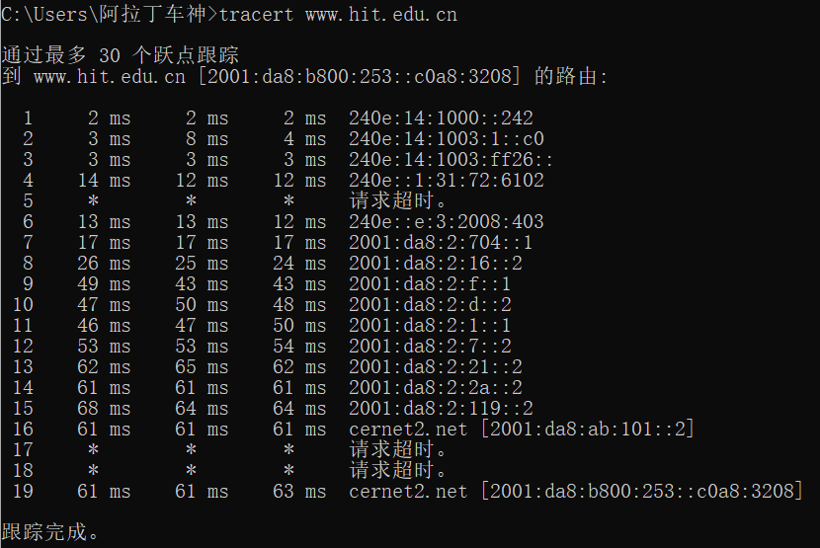

Strategy: tracert a destination as far as possible in from my real world location.

* 1. A destination host on the Internet so that the route from your laptop/desktop to the destination traverses the largest number of ISPs. You can get full credit if it has at least 5 different ISPs, but we encourage you to try to find a longer one. What is your strategy to find such a host?

Solution:

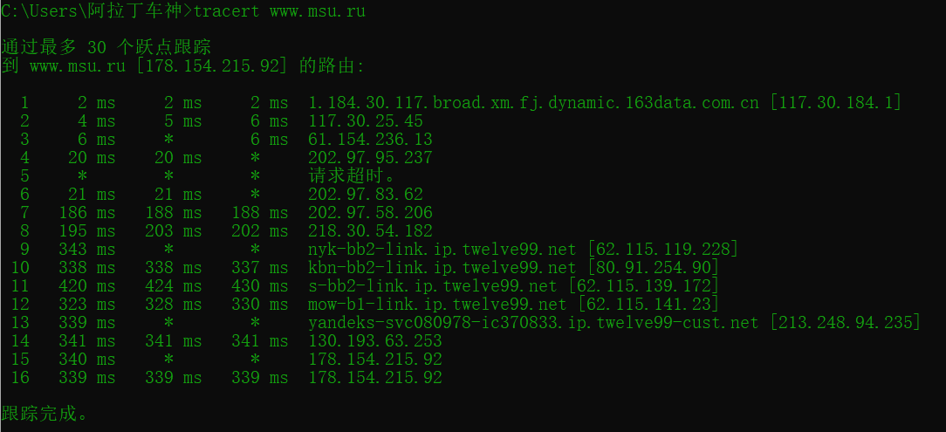

1.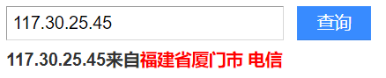

2.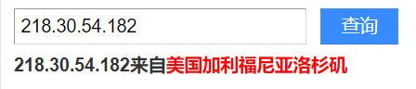

3.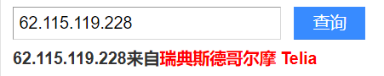

4.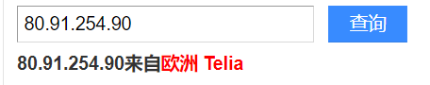

5.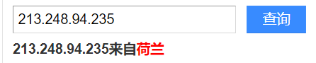

6. 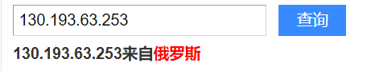

Strategy: choose a transnational route.

* [P2 (10 points)] Suppose the number of people at XMU is 60000. Determine the number of external phone lines that XMU will need in order to achieve a call blocking percentage of 1%. Assume that each person at XMU makes one external phone call per day, and each such phone call lasts on average 3 minutes, with the memoryless distribution.

Solution:

Let N be the number of external phone lines needed, the probability of one person makes a call at a random time is: **3 minutes / 1 day = 3 / 24*60 = 3 / 1440**, and at a random time that the probability of 60000 persons make calls on N lines is: **3 * 60000 / 1440 * N = 0.01 -> N = 12500**. So, the number of external phone lines needed should be 12500.

* [P3 (10 points)] Suppose that you are designing a Web server for your startup. You have acquired a single machine with a quad-core processor. Assume that CPU is the bottleneck. You anticipate that Web requests arrive (memoryless) at a rate of 15 requests/second, and benchmarking shows that it takes a core on average 200 ms to serve a Web request. What is the average service time that each Web request experiences? If it is a dual-core processor, what happens? You need to draw the state diagram when working on this problem.

Solution: Quad-core: average service time: 53.33ms

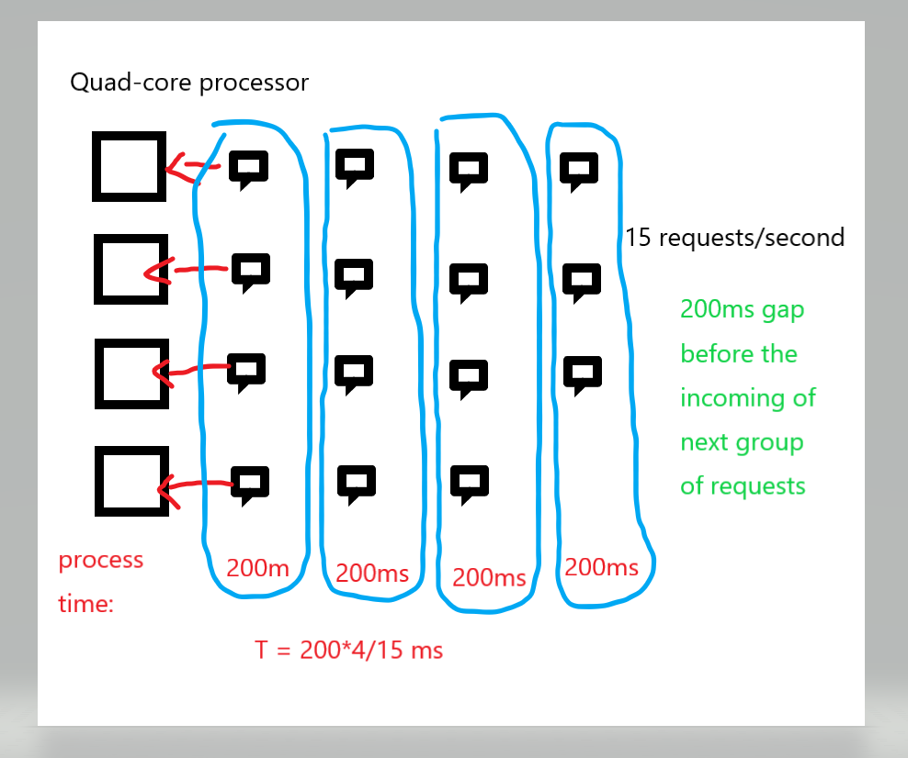

Dual-core: average service time: 100ms

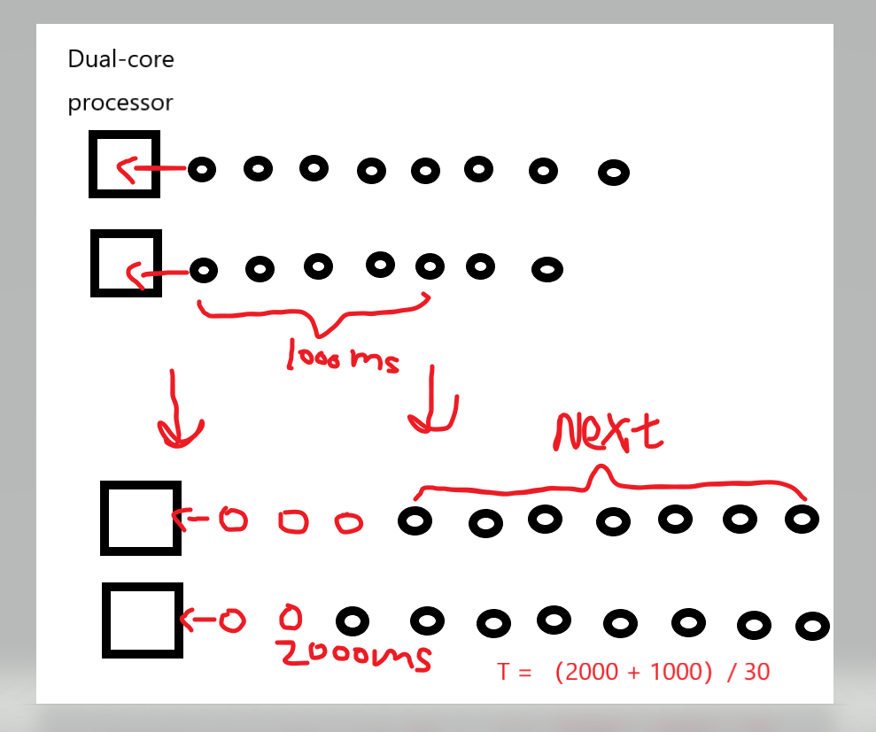

* [P4 (5 points)] This elementary problem explores propagation delay and transmission delay, two central concepts in data networking. Consider two hosts, A and B, connected by a single link of rate *R* bps. Suppose that the two hosts are separated by *m* meters, and suppose the propagation speed along the link is *s* meters/sec. Host A is to send a packet of size *L* bits to Host B.
  1. Express the propagation delay, *d*prop, in terms of *m* and *s*.

Solution: *d*prop =

* 1. Determine the transmission time of the packet, *d*trans, in terms of *L* and *R*.

Solution: *d*trans =

* 1. Ignoring processing and queuing delays, obtain an expression for the end-to-end delay.

Solution: *d*end-to-end = *d*prop + *d*trans = +

* 1. Suppose Host A begins to transmit the packet at time *t* = 0. At time *t* = *d*trans, where is the last bit of the packet?

Solution: At Host A.

* 1. Suppose *d*prop is greater than *d*trans. At time *t* = *d*trans, where is the first bit of the packet?

Solution: In the link between A and B.

* 1. Suppose *d*prop is less than *d*trans. At time *t* = *d*trans, where is the first bit of the packet?

Solution: Arrived at Host B.

* 1. Suppose *s* = 2.5 x 108, *L* = 120 bits, and *R* = 56 kbps. Find the distance *m* so that *d*prop equals *d*trans.

Solution:

*d*prop = *d*trans

* + - =
    - m = Ls/R = 120 x 2.5 x 108 / 56,000 = 535714.2857142857 meters
* [P5 (10 points)] Suppose two hosts, A and B, are separated by 20,000 kilometers and are connected by a direct link of *R* = 2 Mbps. Suppose the propagation speed over the link is 2.5 · 108 meters/sec.
  1. Calculate the bandwidth-delay product, *R* · *d*prop.

Solution: *R* · *d*prop = 2,000,000 · 20,000,000 / (2.5 · 108)

= 1.6 · 105 bits per second

* 1. Consider sending a file of 800,000 bits from Host A to Host B. Suppose the file is sent continuously as one large message. What is the maximum number of bits that will be in the link at any given time?

Solution: Set time as T seconds, the maximum number of bits in the link at time T seconds will be T · R MB.

* 1. Provide an interpretation of the bandwidth-delay product.

Solution:

Bandwidth delay product is a measurement of how many bits can fill up a network link. It gives the maximum amount of data that can be transmitted by the sender at a given time before waiting for acknowledgment. Thus it is the maximum amount of unacknowledged data.

* 1. What is the width (in meters) of a bit in the link? Is it longer than a football field?

Solution:

A width of a bit = length of the link/bandwidth-delay product = 20,000,000/1.6 · 105 = 125 meters, which is longer than a football field.

* 1. Derive a general expression for the width of a bit in terms of the propagation speed *s,* the transmission rate *R,* and the length of the link *m*.

Solution: A width of a bit = $m^{2}$ */ R* · *s*

* [P6 (10 points)] In this problem, we consider sending real-time voice from Host A to Host B over a packet-switched network (VoIP). Host A converts analog voice to a digital 64 kbps bit stream on the fly. Host A then groups the bits into 56-byte packets. There is one link between Hosts A and B; its transmission rate is 2 Mbps and its propagation delay is 10 msec. As soon as Host A gathers a packet, it sends it to Host B. As soon as Host B receives an entire packet, it converts the packet’s bits to an analog signal. How much time elapses from the time a bit is created (from the original analog signal at Host A) until the bit is decoded (as part of the analog signal at Host B)?

Solution: 56*8/64,000 + 56*8/2,000,000 + 0.01 = 0.017224 sec

* [P7 (5 points)] Suppose you would like to urgently deliver 40 terabytes data from Boston to Los Angeles. You have available a 100 Mbps dedicated link for data transfer. Would you prefer to transmit the data via this link or instead use FedEx over-night delivery? Explain.

Solution:

FedEx over-night delivery would be the choice.

For:

Via-link-time = (40*8*10e+12/100*10e+6)/60*60*24 ≈ 37 days. It takes over a month to transmit the data via this link. So it is wiser to use FedEx over-night delivery when you want the data sent urgently.

* [P8 (10 points)] Consider an application that transmits data at a steady rate (for example, the sender generates an N-bit unit of data every k time units, where k is small and fixed). Also, when such an application starts, it will continue running for a relatively long period of time. Answer the following questions, briefly justifying your answer:
  1. Would a packet-switched network or a circuit-switched network be more appropriate for this application? Why?

答：使用电路交换网络更合适。因为数据的传输速率不是突发的，是已知的。且此程序运行时间较长，使用电路交换网络可为每个应用程序占用通信线路带宽，实现低延迟和高利用率。建立和关闭连接的时间在程序的较长运行时间中也显得微乎其微。

* 1. Suppose that a packet-switched network is used and the only traffic in this network comes from such applications as described above. Furthermore, assume that the sum of the application data rates is less than the capacities of each and every link. Is some form of congestion control needed? Why?

答：不需要拥塞控制机制。因为最坏情况下，所有应用同时在网络的线路上发送数据，但每个线路都有充足的带宽供数据传输，因此不会发生拥塞，不需要拥塞控制机制。

* [P9 (10 points)] Suppose users share a 3 Mbps link. Also suppose each user requires 150 kbps when transmitting, but each user transmits only 10 percent of the time. (You can refer to the discussion of packet switching versus circuit switching in Section 1.3.2. of the textbook, if you want.)
  1. When circuit switching is used, how many users can be supported?

Solution:

3 Mbps / 150 kbps = 20 users

So, 20 users can be supported.

* 1. For the remainder of this problem, suppose packet switching is used. You can use either our queueing analysis in class or direct binomial distribution analysis. Find the probability that a given user is transmitting.

Solution: probability = 10% = 1/10 = 0.1

* 1. Suppose there are 120 users. Find the probability that at any given time, exactly *n* users are transmitting simultaneously.

Solution: N = 120

P(n) = C(N,n)

= C(120,n)

* 1. Find the probability that there are 21 or more users transmitting simultaneously.

Solution:

P(21 or more users) = 1 – P($\sum_{j=1}^{120}{X_{j }≤10}$)

P($\sum_{j=1}^{120}{X_{j }≤10}$) = P($\frac{\sum_{j=1}^{120}{X_{j }-4}}{\sqrt{120×0.1×0.9}}≤ \frac{6}{\sqrt{120×0.1×0.9}}$)

= P($Z≤\frac{6}{\sqrt{10.8}}$)

= P($Z≤1.83$) = 0.999

So, P(21 or more users) = 1 – 0.999 = 0.001(appox.)

* [P10 (10 points)] In modern packet-switched networks, including the Internet, the source host segments long, application-layer messages (for example, an image or a music file) into smaller packets and sends the packets into the network. The receiver then reassembles the packets back into the original message. We refer to this process as *message* *segmentation*. The figure below illustrates the end-to-end transport of a message with and without message segmentation. Consider a message that is 8x106 bits long that is to be sent from source to destination in the figure below. Suppose each link in the figure is 2 Mbps. Ignore propagation, queuing, and processing delays.
  1. Consider sending the message from source to destination *without* message segmentation. How long does it take to move the message from the source host to the first packet switch? Keeping in mind that each switch uses store-and-forward packet switching, what is the total time to move the message from source host to destination host?

Solution: ① T1 = 8x106 bits /2 Mbps = 4 sec

② Total = T1 x 3 = 12 sec

* 1. Now suppose that the message is segmented into 800 packets, with each packet being 10,000 bits long. How long does it take to move the first packet from source host to the first switch? When the first packet is being sent from the first switch to the second switch, the second packet is being sent from the source host to the first switch. At what time will the second packet be fully received at the first switch?

Solution: ① T1 = 10,000 bits / 2Mbps = 0.005 sec

② T2 = 0.005 + 0.005 = 0.01 sec

* 1. How long does it take to move the file from source host to destination host when message segmentation is used? Compare this result with your answer in part (a) and comment.

Solution: ① 0.005*3+799*0.005 = 4.01 sec

② 12 sec compared with 4.01, apparently delay that using message segmentation is significantly less.(approx. 1/3)

* 1. In addition to reducing delay, what are reasons to use message segmentation?

Solution:

 1) Without message segmentation, if bit errors are not tolerated, if there is a single bit error, the whole message has to be retransmitted (rather than a single packet). 2) Without message segmentation, huge packets (containing HD videos, for example) are sent into the network. Routers have to accommodate these huge packets. Smaller packets have to queue behind enormous packets and suffer unfair delays.

* 1. Discuss the drawbacks of message segmentation.

Solution:

1) Packets have to be put in sequence at the destination. 2) Message segmentation results in many smaller packets. Since header size is usually the same for all packets regardless of their size, with message segmentation the total amount of header bytes is more.

|  |
| --- |
| **Figure for P10:**End-end message transport: (a) without message segmentation; (b) with message segmentation. |

* [P11 (10 points)] Consider sending a large file of *F* bits from Host A to Host B. There are three links (and two switches) between A and B, and the links are uncongested (that is, no queuing delays). Host A segments the file into segments of *S* bits each and adds 80 bits of header to each segment, forming packets of *L* = 80 + *S* bits. Each link has a transmission rate of *R* bps. Find the value of *S* that minimizes the delay of moving the file from Host A to Host B. Disregard propagation delay.

Solution:

T = 3*L/R+((F/S)-1)*L/R, L = 80 + S

T = ((80+S)/R)(F/S + 2)

To get extremum, set $\frac{dT}{dS}$ = 0

$\frac{dT}{dS}$ = 0

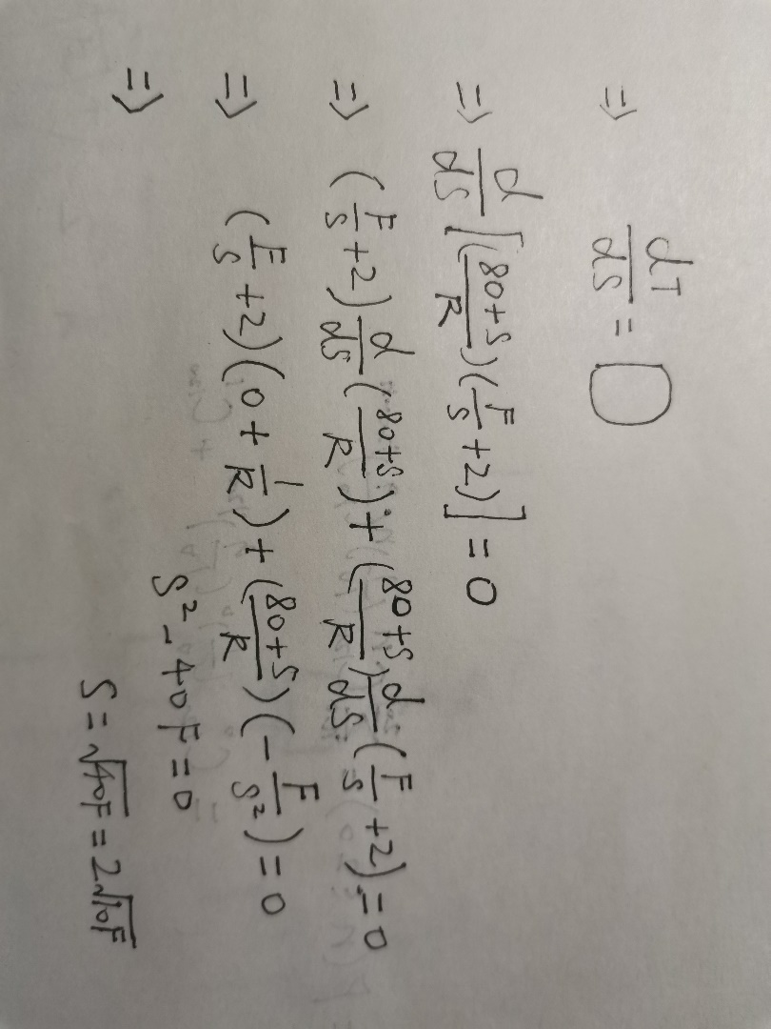

The value of S that minimizes the the delay is $2\sqrt{10F}$

* [P12 (5 points)] Skype is a software that allows you to make a phone call from a PC to an ordinary phone. This means that the voice call must pass through both the Internet and through a telephone network. Discuss how this might be done.

Solution:

Protocol like VoIP: The analog signal is converted into data packet through VOIP terminal computer. The data packet is transmitted to another VOIP terminal computer on the Internet. The VOIP terminal computer converts the data packet into analog signal, and the analog signal is converted into sound through telephone. This is done between computers. To make a call from PC to phone, the data packet needs to be transmitted from internet to telephone network.

**Therefore, Skype uses its proprietary protocol and the interface between the internet and telephone networks to make a voice call from a PC.**